http://www.landmarkmlp.com/js-plugin/owl.carousel/demos/images.html:

Owl Carousel – Content with Images
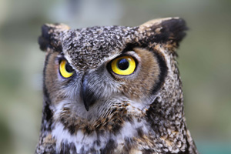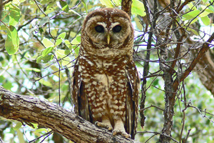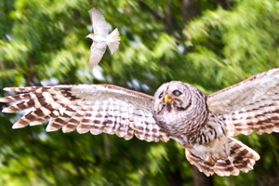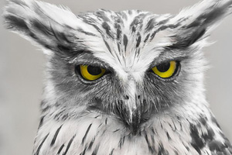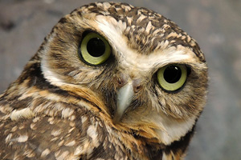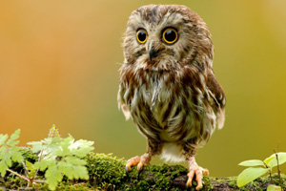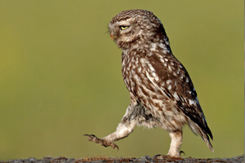

Setup
In order for the images to auto fit to slider containers use width 100% on <img>. Check CSS below
JavaScript:
- $(document).ready(function() {

- $("#owl-demo").owlCarousel({

- autoPlay: 3000, //Set AutoPlay to 3 seconds

- items : 4,
- itemsDesktop : [1199,3],
- itemsDesktopSmall : [979,3]

- });

- });
HTML:
- <div id="owl-demo">

- <div class="item"><img src="assets/owl1.jpg" alt="Owl Image"></div>
- <div class="item"><img src="assets/owl2.jpg" alt="Owl Image"></div>
- <div class="item"><img src="assets/owl3.jpg" alt="Owl Image"></div>
- <div class="item"><img src="assets/owl4.jpg" alt="Owl Image"></div>
- <div class="item"><img src="assets/owl5.jpg" alt="Owl Image"></div>
- <div class="item"><img src="assets/owl6.jpg" alt="Owl Image"></div>
- <div class="item"><img src="assets/owl7.jpg" alt="Owl Image"></div>
- <div class="item"><img src="assets/owl8.jpg" alt="Owl Image"></div>

- </div>
CSS:
- #owl-demo .item{
- margin: 3px;
- }
- #owl-demo .item img{
- display: block;
- width: 100%;
- height: auto;
- }

